AWS CLOUD COMPUTING
PRACTICAL REPORT
TASK 21 — E-COMMERCE DATABASE (K4)
Submitted by
VISHNUPRIYAN P R-24AM118

1. Aim
To design a secure, scalable cloud database solution for ShopWorld, an e-commerce application, using AWS networking, compute, database, identity, and monitoring services.

2. Problem Statement
ShopWorld needs a database-backed application to manage products, customers, orders, and inventory. The solution should separate public application access from the private database tier, apply least-privilege access controls, and support operational monitoring.

4. Proposed AWS Architecture
The design separates the internet-facing application tier from the database tier. The application server communicates with the database through explicitly allowed traffic. The database is planned for private subnets and should not be exposed directly to the public internet.

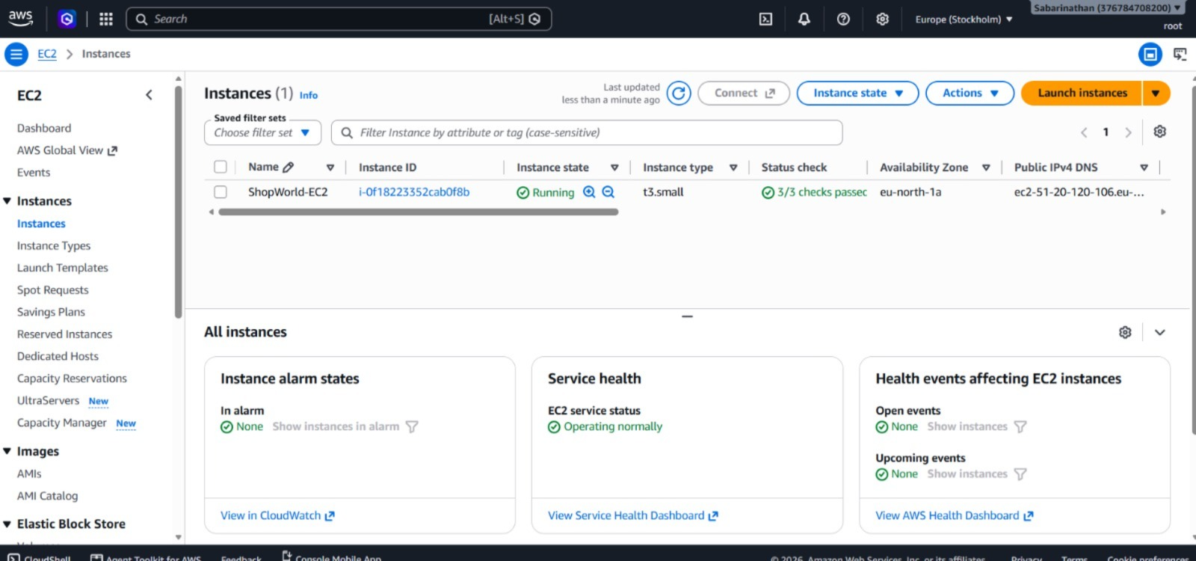

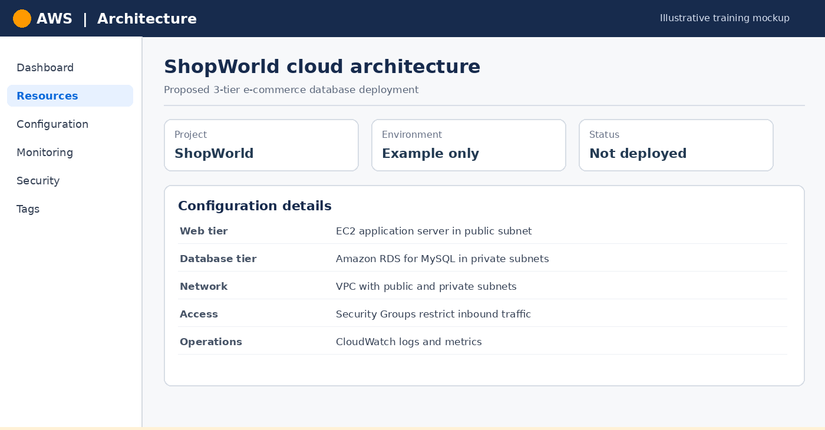

5. AWS Services Used
Service | Purpose in ShopWorld | Design note
Amazon VPC | Isolated network for ShopWorld resources | Use separate public/private subnets
Amazon EC2 | Runs the application tier | Restrict inbound access
Amazon RDS | Managed relational database | Keep database private
IAM | Controls identities and permissions | Least privilege; avoid hard-coded keys
Security Groups | Controls resource-level network traffic | Allow only required sources and ports
Amazon CloudWatch | Monitoring and alerting | Configure metrics, logs, and alarms

6. Database Configuration (Illustrative)
A MySQL-compatible RDS database is one possible implementation. The final engine, capacity, backup retention, encryption, and availability settings must be selected according to the actual assignment requirements and budget.

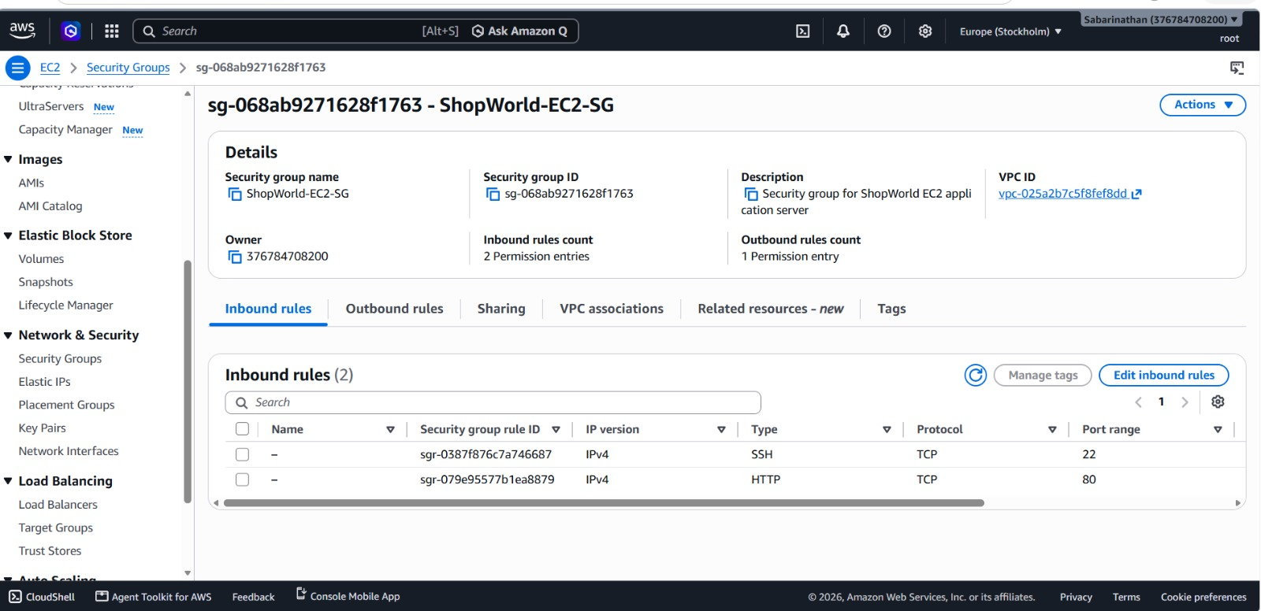

7. VPC and Subnet Plan (Illustrative)
The following sample CIDR ranges are only a planning example. Check for address overlap with existing networks before creating resources.

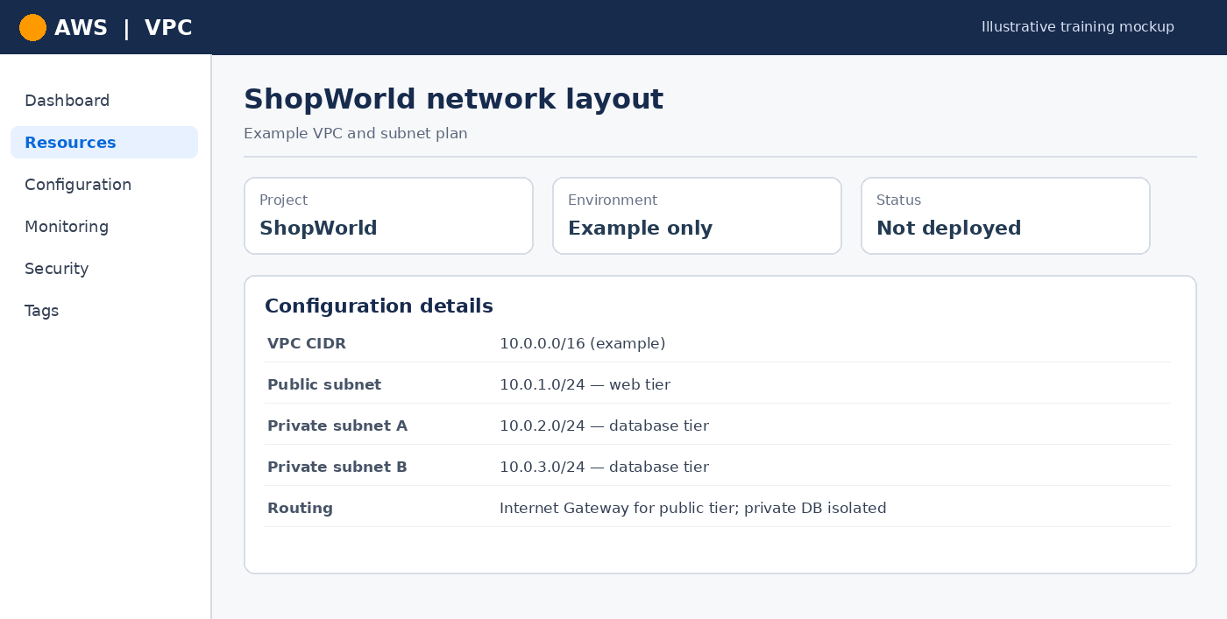

8. EC2 Application Connectivity
The application tier should connect to the RDS endpoint using the configured database port and credentials managed securely. The connection should be tested from the application environment after deployment; this report does not claim that such a test has been executed.
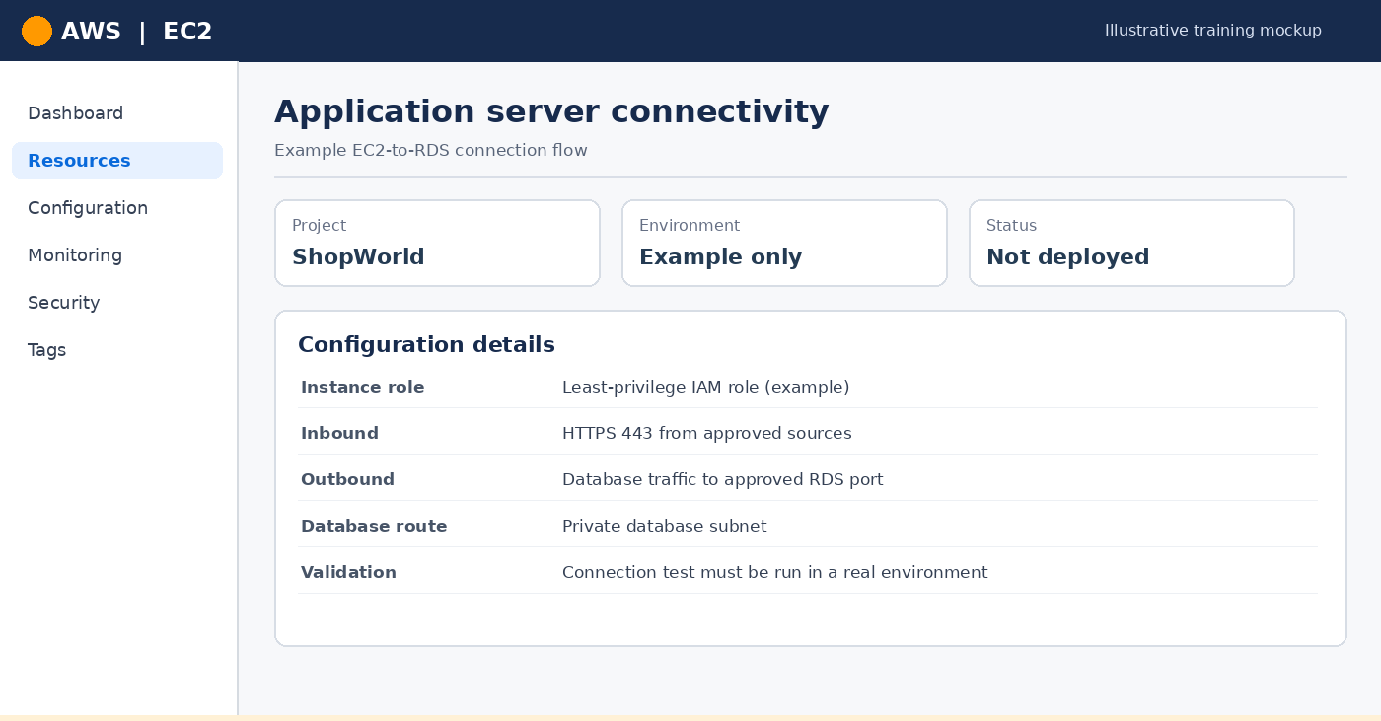

9. Security Group Design
Use separate security groups where appropriate. The database security group should accept database traffic only from the application tier, rather than from unrestricted public sources.

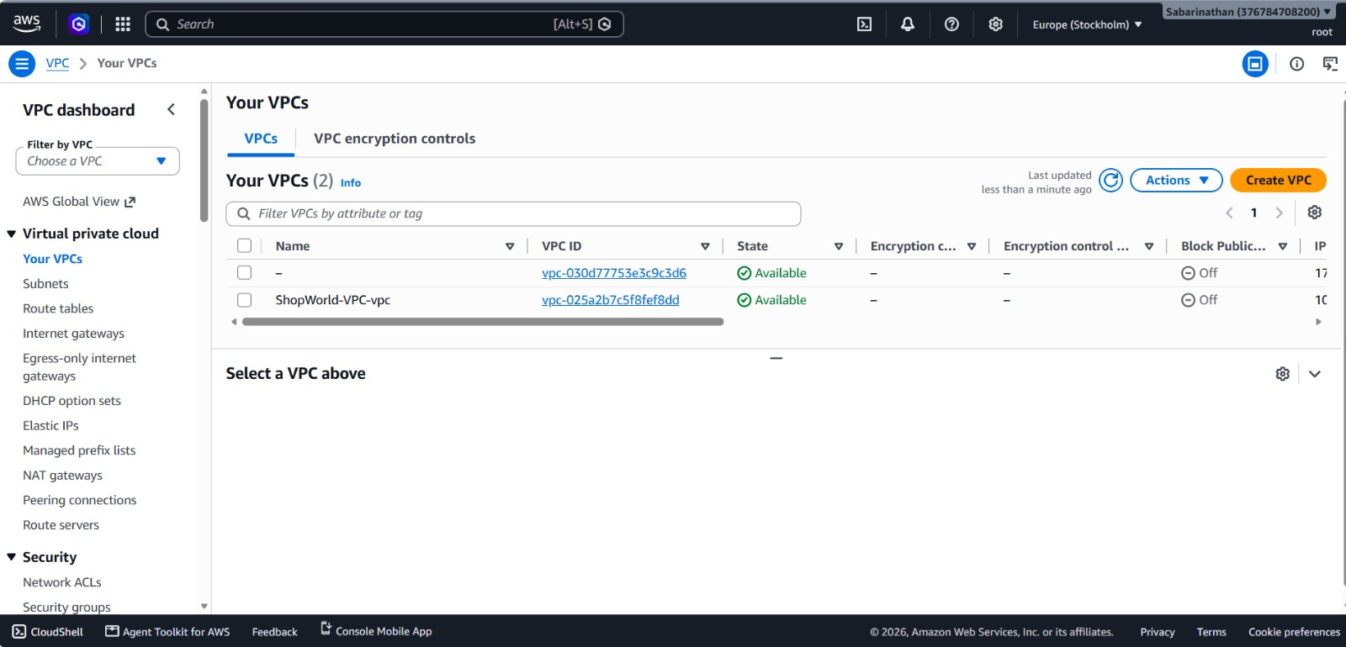

10. IAM Access Management
Assign an IAM role to the application workload when it needs AWS API access. Grant only the permissions needed for the intended functions, enable multi-factor authentication for human access, and review activity regularly.

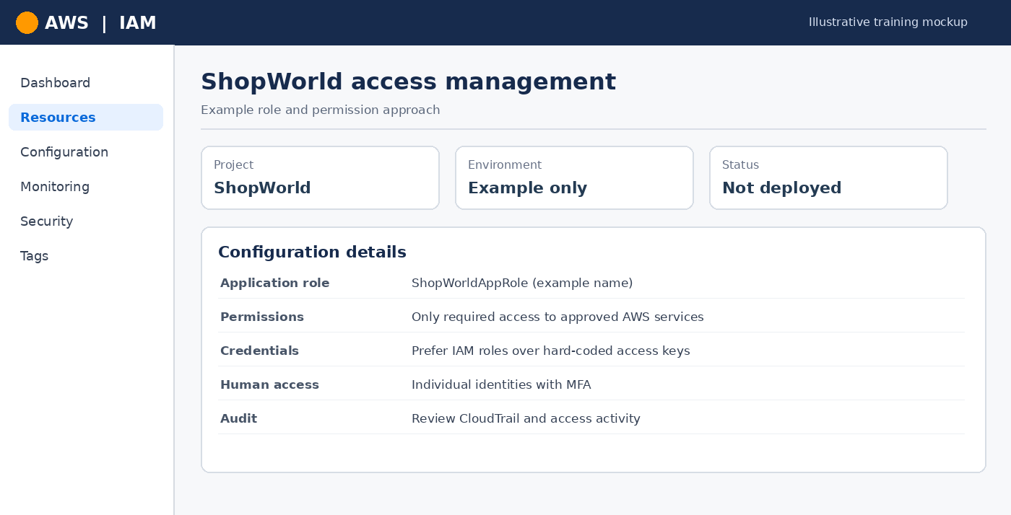

11. SQL Schema and CRUD Operations
The following SQL snippets demonstrate the type of product-table operations a ShopWorld database may require. Run them only in a prepared test database and adapt types and constraints to the final schema.
CREATE TABLE Products (
product_id INT PRIMARY KEY,
name VARCHAR(100) NOT NULL,
price DECIMAL(10,2) NOT NULL,
stock INT NOT NULL DEFAULT 0
);
INSERT INTO Products (product_id, name, price, stock)
VALUES (1, 'Sample Product', 499.00, 20);
SELECT product_id, name, price, stock FROM Products;
UPDATE Products SET stock = 18 WHERE product_id = 1;
DELETE FROM Products WHERE product_id = 1;

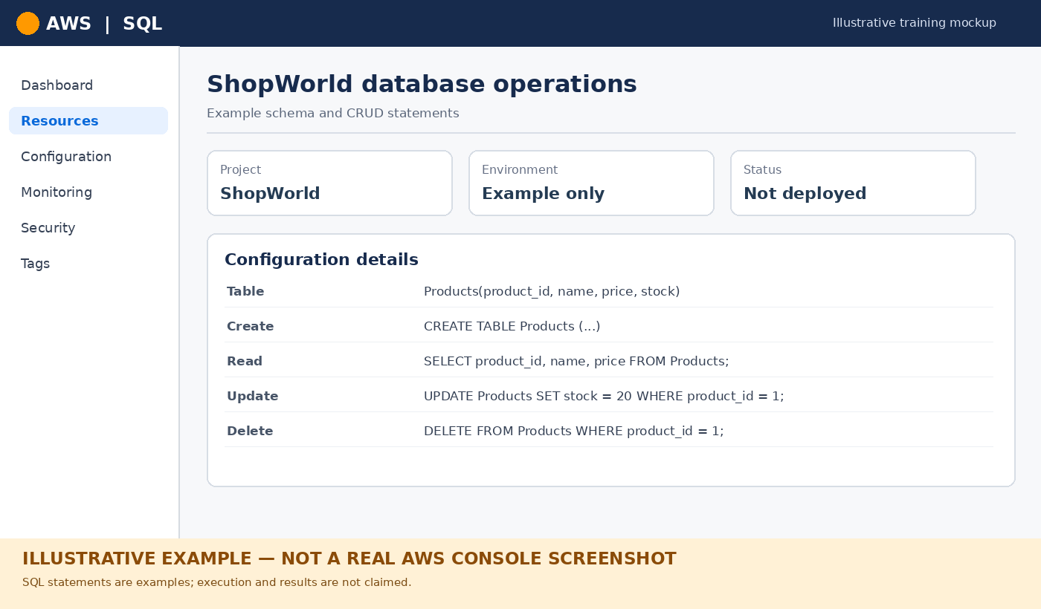

12. Monitoring with CloudWatch
CloudWatch can be used to observe application and database performance. Select relevant metrics and logs, create alarms based on meaningful thresholds, and verify the alarm behavior after the resources are deployed.

13. Testing and Validation Plan
Test | How to validate | Status in this report
Network isolation | Verify RDS is not publicly accessible and routes are correct | Planned — not executed here
Security Groups | Confirm only approved sources/ports are allowed | Planned — not executed here
Database connectivity | Connect from the application host using approved credentials | Planned — not executed here
CRUD operations | Run INSERT, SELECT, UPDATE, DELETE against test data | SQL examples provided; not executed here
Monitoring | Verify metrics/logs and trigger a test alarm | Planned — not executed here

14. Security Best Practices
- Keep the database in private subnets and disable public accessibility unless a documented requirement says otherwise.
- Use least-privilege IAM policies and role-based access for workloads.
- Store database credentials in an appropriate secrets-management service; do not commit credentials to source control.
- Enable encryption at rest and in transit where supported and required.
- Configure backups, retention, and recovery procedures appropriate to the application.
- Review logs, alerts, and access permissions periodically.

15. Result
A proposed AWS architecture and implementation plan for the ShopWorld e-commerce database has been documented, including network segmentation, compute/database responsibilities, access controls, example SQL operations, and monitoring considerations. Actual deployment, execution, and validation remain to be completed and recorded with genuine evidence.

